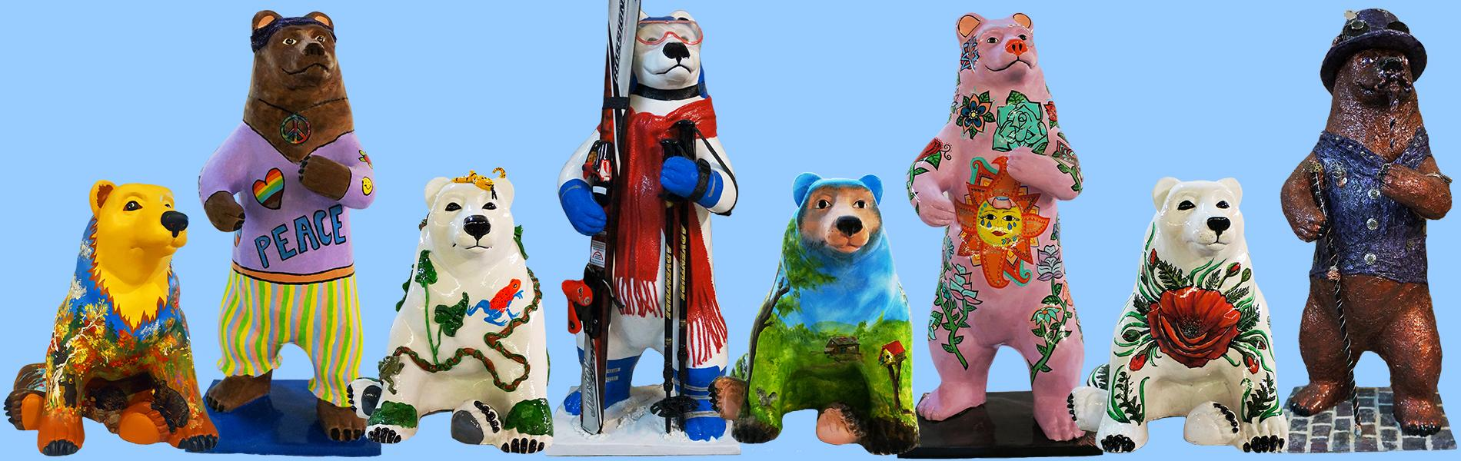

Cairo Bears Community
Art Project
Sponsor Packet
2027

Sponsored by
Cairo Development Foundation
PO Box 251
Cairo, NY 12413

Questions? Contact Adrianna Maselli-Thierault
914-760-3924
cdfcommunityart@gmail.com

www.cairodf.com

Welcome to the Cairo Bears & Woodland Animals Community Art Project

Once again, Cairo Bears & Woodland Animals will grace the streets of Cairo, Acra, Round Top, Purling, and South Cairo. The Cairo Development Foundation administers the Cairo Bears & Woodland Animals Community Art Project as a fundraiser to benefit the Cairo Development Foundation, the Town of Cairo, and surrounding communities.

We are cordially inviting you to sponsor a bear or woodland animal! They will be decorated by a juried artist who will be assigned you, the sponsor, and by the “Cairo Bears & Woodland Animals Community Art Project 2025” Committee. Bears will be on display all summer throughout the Town of Cairo and will be auctioned on the 3rd weekend on September 18, 2027.

How does The Bears & Woodland Animals Community Art Project work?

Artists wishing to participate will create colored sketches of designs for a fiberglass bear and/or woodland animal with a standing or sitting position. Completed designs will be submitted by December 15th and then our committee will choose an artist and a design for you. The Artists will then transform their bears for the May unveiling. Bears and woodland animals will be on display from Memorial Day through Labor Day.

Where do the Bears and Woodland Animals Go After the Summer?

Following their summer on the street, the bears are auctioned off at our “Cairo Bears & Woodland Animals Community Art Project” Auction. The profits are then divided up. Firstly, in profound appreciation for the work done by our artists, they will receive a percentage of the gross amount for which their bear is auctioned. The rest of the proceeds will go towards the Cairo Development Foundation for future projects to beautify and improve the Town of Cairo and promote a business-friendly atmosphere in our community.

All Sponsor names will appear on the
Official Cairo Bears & Woodland Animals Community Art Project Guide and Map.
Our goal is to have 35 Bears featured throughout the Town of Cairo. Memorial Day – To Labor Day 2027.

Be sure to sign up for your bear before the cubs are all adopted!!
This is a COMMUNITY WIDE PUBLIC ART event and we encourage participation by all businesses, organizations, and individuals. This fundraiser helps to move Cairo forward in a positive and community-oriented way!

Become a sponsor today!!!
For more information contact Adrianna Maselli-Thierault or e-mail cdfcommunityart@gmail.com

Sponsor a Cairo Bear or Woodland Animal

Cairo Bear & Woodland Sponsor - $600
Supports one decorated Bear and will receive the following:

- Sponsored Bear displayed in front of your place of business for the season
- Sponsor name recognition on “Cairo Bears & Woodland Animals Community Art Project 2027” Guide & Map
- Plaque on the bear or woodland animal display platform indicating Sponsor, Artist and Bear’s name
- Recognition at the Cairo Bears & Woodland Animals Auction on September 18, 2027
- 1 Ticket to the Cairo Bears & Woodland Animals Auction which includes a meal.

2027 Sponsor Timeline

January 31, 2027 Completed and signed sponsor packet and payment due unless other arrangements have been made for payments.

February 14, 2027 Sponsors do not choose a design, CDF staff will select one on their behalf. You may request one but selection is the sole discretion of the Community Art Project Committee.

Late May 2027 Bear installation begins in time for Memorial Day
Weekend

June – September Bears on display on the streets Memorial Day thru
Labor Day

September 18, 2027 Cairo Bears & Woodland Animals Auction

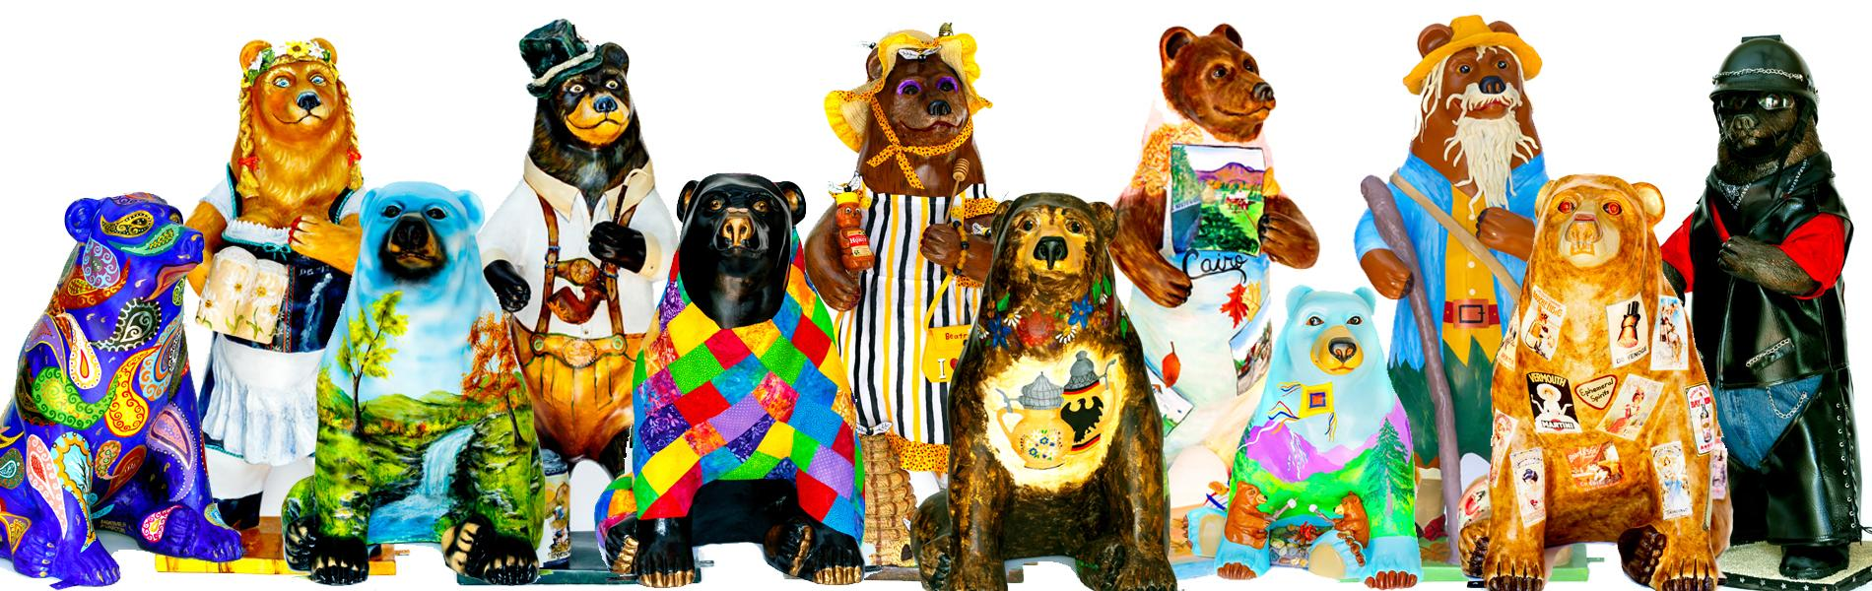
Cairo Bears & Woodland Animals Community Art Project 2027

Sponsors Agreement

Print and mail this form with check or complete online at www.cairodf.com
Please clearly print or type all information

Sponsor(s):_____________________________________________________________________________________________________

Contact Name(s):______________________________________________________________

Mailing Address:______________________________________________________________

City:_____________________________________State:____________Zip:_______________

Bear Location requested:________________________________________________________

Primary Telephone #:_____________________Secondary Telephone#___________________

E-mail:______________________________________________________________________

Woodland Animal Sponsor $600 ______________

I understand and acknowledge that Cairo Development Foundation shall be the sole and exclusive owner of the entire right, title and interest in and to the Cairo Bear & Woodland Animal Design. Sponsors will not make any changes or alterations to the bears without prior written permission of both the Cairo Bears & Woodland Animals Committee and the artist of the bear’s design. All bears will be auctioned off to the highest bidder on Saturday, September 18, 2027.

Payment is due in full at time of commitment unless other arrangements are made. Last day to submit payments is January 31, 2027, unless other arrangements have been made. Please return this form with your check made out to: Cairo Development Foundation, PO Box 251. Cairo, New York 12413

Sponsor Signature: _________________________________________ Date: ___________
Or Fill out form and pay online Sponsors, can pay online at www.cairodf.com

