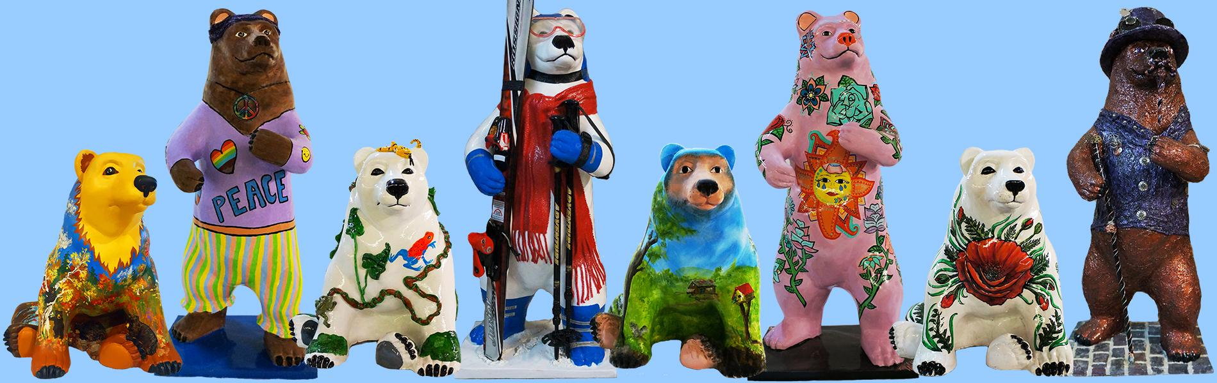

Cairo Bears Community
Art Project
Sponsor Packet
2024

Sponsored by
Cairo Development Foundation
PO Box 251
Cairo, NY 12413

Questions? Contact Sherry B. True 410-935-0072
cdfbears467@gmail.com

www.cairodf.com

Welcome to the Cairo Bears Community Art Project

Once again, Cairo Bears will grace the streets of Cairo, Acra, Round Top, Purling, and South Cairo. The Cairo Development Foundation administers the Cairo Bears Community Art Project as a fundraiser to benefit the Cairo Development Foundation, the Town of Cairo, and surrounding communities.

Make plans to host a decorated fiberglass bear for the summer. They will be decorated by a juried artist who will be selected by you, the sponsor, and by the “Cairo Bears Community Art Project 2024” Committee. Bears will be on display all summer throughout the Town of Cairo and will be auctioned on the 4th weekend in September, 28 2024.

How does The Bears Community Art Project work?

Artists wishing to participate will create colored sketches of designs for a fiberglass bear with a standing or sitting position. Completed designs will be submitted by November 30th and then our committee will work with you to choose an artist and a design to your liking. The Artists will then transform their bears for the May unveiling. Bears will be on display from Memorial Day through Labor Day.

Where do the Bears Go After the Summer?

Following their summer on the street, the bears are auctioned off at our “Cairo Bears Community Art Project” Auction. The profits are then divided up. Firstly, in profound appreciation for the work done by our artists, they will receive a percentage of the gross amount for which their bear is auctioned. The net proceeds will go towards the Cairo Development Foundation for future projects to beautify and improve the Town of Cairo and promote a business-friendly atmosphere in our community.

All Sponsor names will appear on the
Official Cairo Bears Community Art Project Guide and Map.
Our goal is to have 56 Bears featured throughout the Town of Cairo. Memorial Day – To Labor Day 2024.

Be sure to sign up for your bear before the cubs are all adopted!!
This is a COMMUNITY WIDE PUBLIC ART event and we encourage participation by all businesses, organizations, and individuals. This fundraiser helps to move Cairo forward in a positive and community-oriented way!

Become a sponsor today!!!
For more information contact Sherry B. True at 410-935-0072 or e-mail cdfbears467@gmail.com
Sponsor a Cairo Bear

Cairo Bear Corporate Chain Sponsor - $800
Supports one decorated Bear and will receive the following:

- Sponsored Bear displayed in front of your place of business for the season
- Sponsor name recognition on “Cairo Bears Community Art Project 2023” Guide & Map
- Plaque on the Bear display platform indicating Sponsor, Artist and Bear’s name
- Recognition at the Cairo Bears Auction on September 28, 2024
- 1 Ticket​ to the Cairo Bears Auction

Cairo Bear Sponsor - $600
Supports one decorated Bear and will receive the following:

- Sponsored Bear displayed in front of your place of business for the season
- Sponsor name recognition on “Cairo Bears Community Art Project 2023” Guide & Map
- Plaque on the Bear display platform indicating Sponsor, Artist and Bear’s name
- Recognition at the Cairo Bears Auction on September 28, 2024
- 1 Ticket to the Cairo Bears Auction

2024 Sponsor Timeline

January 10, 2024 Completed and signed sponsor packets and payments due unless other arrangements have been made for payments.

Jan-Feb 2024 Artist designs distributed to sponsors for selections.

February 14, 2024 Deadline for sponsor’s selection of bears. If sponsors do not choose a design, CDF will select one on their behalf.

Late May 2024 Bear installation begins in time for Memorial Day
Weekend

June - September Bears on display on the streets Memorial Day thru
Labor Day

September 28, 2024 Cairo Bears Auction

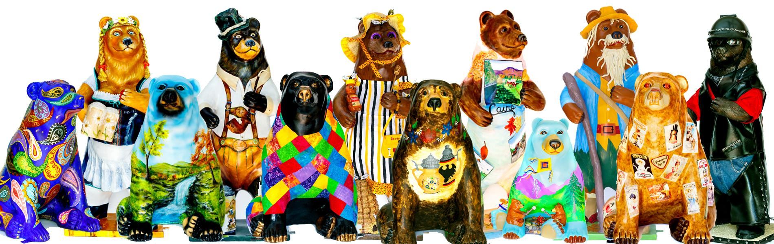
Cairo Bears Community Art Project 2024
Sponsors Agreement

Print and mail this form with check or complete online at www.cairodf.com
Please clearly print or type all information

Sponsor(s):_____________________________________________________________________________________________________

Contact Name(s):______________________________________________________________

Mailing Address:______________________________________________________________

City:_____________________________________State:____________Zip:_______________

Bear Location requested:________________________________________________________

Primary Telephone #:_____________________Secondary Telephone#___________________

E-mail:______________________________________________________________________

Bear Corporate Chain Sponsor $800_____________ Bear Sponsor $600 ______________

I understand and acknowledge that Cairo Development Foundation shall be the sole and exclusive owner of the entire right, title and interest in and to the Cairo Bear Design. Sponsors will not make any changes or alterations to the bears without prior written permission of both the Cairo Bears Committee and the artist of the bear’s design. All bears will be auctioned off to the highest bidder on Saturday, September 28 2024.

Payment is due in full at time of commitment unless other arrangements are made. Last day to submit payments is January 31, 2024 unless other arrangements have been made. Please return this form with your check made out to: Cairo Development Foundation, PO Box 251. Cairo, New York 12413

Sponsor Signature: _________________________________________ Date: ___________
Or Fill out form and pay online Sponsors, can pay online at www.cairodf.com

