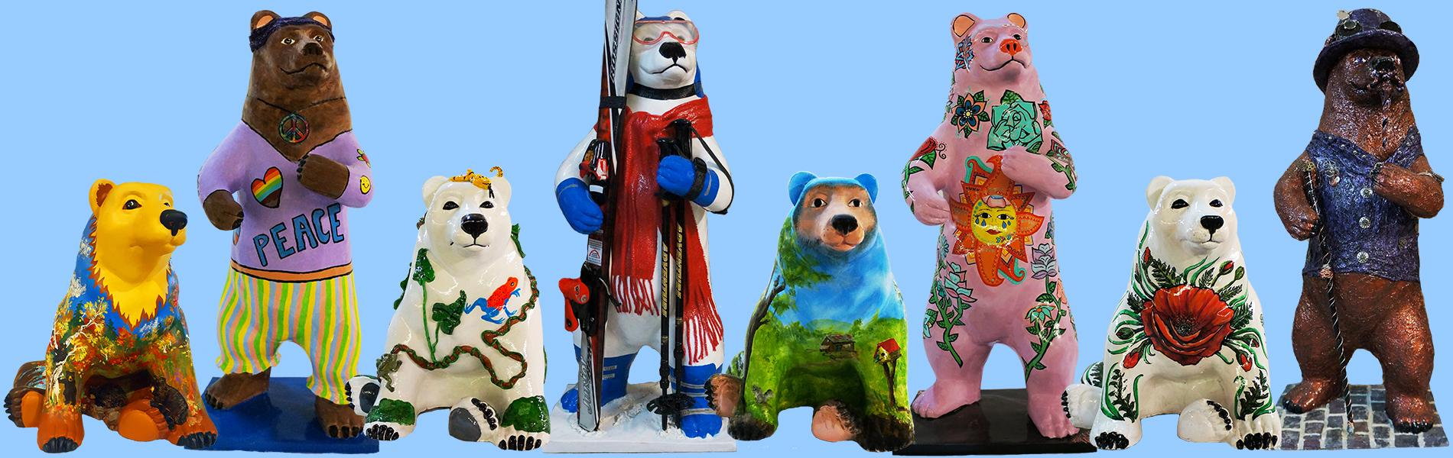

Artist’s Packet
Cairo Bears
Community Art Project
2024

Sponsored by
Cairo Development Foundation
PO Box 251
Cairo, NY 12413

Questions? Contact Sherry B. True
410-935-0072
cdfbears467@gmail.com

www.cairodf.com
Calling All Artists!

The Cairo Bears will be returning for the summer of 2024! This is a very exciting new season for the Cairo Development Foundation and the Town of Cairo. Once again, Cairo Bears will grace the streets of Cairo, Acra, Roundtop, Purling, South Cairo! The Cairo Development Foundation is administering the Cairo Bears Community Art Project as a fundraiser to benefit the Cairo Development Foundation’s Main Street Revitalization Program in the Town of Cairo. We are counting on all of you wonderful artists out there to create incredible, original artwork that will amaze both local bear lovers and those who will travel from far and wide to see the Cairo Bears!

Participating in “Cairo Bears Community Art Project” is a great way for artists to gain public recognition. Both sponsors and artists will be promoted in both print and social media, at events, and on the streets! There will be many promotions and special events throughout the season circulating your name and artwork to the public!

Artists wishing to participate will create colored sketches of their designs for a fiberglass bear available either in a sitting or standing position. While you have complete freedom with your design, one thing to take into consideration is that some of our sponsors are looking for designs that complement their businesses. Please stick with the original design you submitted as much as possible as that is what the sponsor is expecting to see. If you need to deviate from your submitted sketch you need to contact the Program Director, Sherry True.

PLEASE USE A TWO-PART EPOXY GLUE TO SECURE ITEMS THAT NEED TO BE GLUED. J-B WELD CLEAR OR ANOTHER TWO-PART EPOXY GLUE IS RECOMMENDED.

Completed designs need to be submitted to the Cairo Bears Committee for the selection process. It is essential that all designs be submitted by November 30, 2023. Any designs submitted after the due date are at risk of not being chosen by a sponsor. Once the design has been approved by the committee, your design will be circulated to available sponsors. Once all sponsors have chosen an artist’s design, our office will notify you whether or not your design was selected by a sponsor.

The bears will be ready to be picked up at the Cairo Development Foundation office in late January or early February, and over the next several months, artists will transform their bears for the Memorial Day weekend unveiling. The bears will be on display in Cairo, Windham and the surrounding communities from Memorial Day through Labor Day. Following their summer on the street the bears will be auctioned at the Cairo Bears Auction on Saturday, September 28, 2024.

In profound appreciation for the work done by our artists, you will receive a 25% share of the gross amount for which the bear is auctioned. Artists who return their work by the due date will receive the 25%. However, artists who do not deliver their completed bears by the due date will receive a smaller percentage. The tardiness of even one bear delays the timely production of the brochure.
Selection & Approval Process

- The Cairo Bears Committee will review all submission packages for inclusion in the project.

- Designs approved by the committee will be presented to the sponsors for consideration. The sponsor will make the final selection of the design and notify the Cairo Development Foundation.

- All artists will be informed whether or not their design has been selected by a sponsor.

- Artists will receive $50 compensation for supplies.

- Artists will receive 25% commission from the gross auction price of the bear if the bear is completed by the due date, April 15, 2024. Only partial commission will be paid for submissions after the due date, depending on how late the artwork is submitted. Please, this is VERY important if the brochure and the BEARS are to be out by Memorial Day!!!!!

- PLEASE USE A TWO-PART EPOXY GLUE TO SECURE ITEMS THAT NEED TO BE GLUED. J-B WELD CLEAR OR ANOTHER TWO-PART EPOXY GLUE IS RECOMMENDED.

- DO NOT USE PAPER OR CARDBOARD FOR ANY ITMES ON THE BEAR. THEY DO NOT WEATHER.

What Needs to Be Submitted?

- Artist Agreement (signed)

- Copyright Agreement (signed)

- W-9 (signed)

- A color sketch of your Bear design on 8½” x 11” paper

- Artist bio or resume for posting on the CDF website. Please email to cdfbears467@gmail.com

Artist Timeline

Fall 2023 Artists Packets available
November 30, 2023 Deadline for Artist Submission
January 2024 Bears selected by Sponsors
February 2024 Artist Notification of selection. Bears available for pick-up by Artists.
April 15, 2024 Bears MUST be completed and returned to CDF
May 2024 Bears Installation begins in time for Memorial Day Weekend
September 28, 2024 Cairo Bears Auction

Please Note: It is imperative you adhere to the schedule so the program can run smoothly.

Acknowledgement for Artists

Artists participating in “Cairo Bears Community Art Project” 2024 will be acknowledged in the following ways:

- The artist, title, and sponsor of each bear will be displayed on a plaque which will be mounted on the base of each Bear.

- The artist, title, and sponsor of each bear will be listed in the “Cairo Bears Community Art Project” brochure which will include a map that indicates the location of each bear in the Cairo area.

- The artist, title, and sponsor of each Bear will be listed on the Cairo Development Foundation website, www.cairodf.com under the link “Cairo Bears Community Art Project”.

- The Bear, along with its artist and sponsor, will be featured in both print and social media throughout the season.

- Artists, sponsors and bears will all be honored at the Cairo Bears Auction on September 28, 2024. Artists will receive one free ticket to the Gala.

Resources for Artists

Artists are encouraged to view websites that provide information about similar projects that have taken place in other communities. Cowpainters maintains a website that lists all the programs for which they supply forms. By visiting them at www.cowpainters.com and clicking on the “Projects” tab you can view projects that are taking place in many other cities.

Cowpainters from Chicago is where we will be ordering our fiberglass forms. In addition to the forms, they also provide important consultative services, such as the "Prep & Painting Tips"© for artists and their unique Artists' Hotline info@cowpainters.com assures that the artists get the expert technical guidance they need.

Contact Us

Cairo Development Foundation
Sherry B. True, Cairo Bear Community Art Project Coordinator
PO Box 251
Cairo, NY 12413
410-935-0072
cdfbears467@gmail.com
www.Cairodf.com
Cairo Bears Community Art Project
Artist’s Agreement
Deadline for submission – November 30, 2023
Please complete fully and print clearly

Artist Name: ___________________________________________________________________________________
(Exactly as you want it to appear on plaque and in print)

Mailing Address: _______________________________________________________________________________

City: ______________________________________________ State: _______________ Zip: __________________

Daytime Phone: __________________________________ Evening Phone: ________________________________

E-mail Address: _________________________________________________________________________________

Website Address: ________________________________________________________________________________

Title of Your Bear: _______________________________________________________________________________

Bear Style Choice: Standing Bear __________ Sitting Bear __________

Email to cdfbears467@gmail.com ⃞ Artist Bio ⃞ Design Statement (brief description of design)

Attached: ⃞ Copyright Agreement (signed) ⃞ W-9 (signed) ⃞ Color 8½” x 11” sketch of Bear design

Assurances: (Please Initial)
________ I have completely read the Cairo Bears Community Art Project Artist Packet, including the Artist Guidelines, Technical Notes & Design Criteria, and agree to its contents in full.
________ I acknowledge that all application materials will become the property of the Cairo Development Foundation and no materials will be returned to the artist.
________ I understand and acknowledge that Cairo Development Foundation shall be the sole and exclusive owner of the entire right, title and interest in and to the Cairo Bear Design and of the bear form itself.
________ I understand that all bears will be auctioned off to the highest bidder on Saturday, September, 28 2024, and that the auction date may be subject to change without notice.
________ I understand that my final, completed bear must be returned to the Cairo Development Foundation no later than April 15, 2024, in order to receive the full 25% commission from the fall 2024 auction.
________ I understand that I could be subject to civil penalties in the event that I accept any funds or materials from the Cairo Development Foundation and then fail to supply a finished bear for outdoor display for the summer of 2024.
________ I understand that in the event that I am unable or unwilling to make repairs to my bear should it suffer from vandalism, accident, or other incident that causes damage to the Bear, the Bear Committee reserves the right to make such repairs at its discretion. In such case, the cost of repairing said bear may be deducted from any commission that the Artist may earn from the auction proceeds.
________ The Bear Committee reserves the right to make changes or repairs to the bears at any time if the committee deems that it is in the best interest of the Cairo Development Foundation.

Artists Signature: _______________________________________ Date: _________________

If the Artist is under the age of 18, a parent or guardian’s consent and supervision is required.

Supervising Adult Signature: _______________________________________ Date: _________________
Copyright Assignment

WHEREAS, ________________________________________ (artist’s name), an individual having an address at ______________________________________________________is the Author of the design and sketches (collectively referred to as the “Design”) attached to the application submitted to the Cairo Development Foundation’s Cairo Bears Community Art Project committee on the same date of this assignment;

WHEREAS, the Artist understands and acknowledges that, as part of the application process, it is intended that the Cairo Development Foundation, with an address of PO Box 251, Cairo, NY 12413, owns the entire right, title and interest in and to the Design. The Artist desires to transfer all of his/her right, title and interest in and to the Design, including but not limited to, all derivative works which are based on the Design to the Cairo Development Foundation.

WHEREAS the Artist understands and acknowledges that he/she will be notified in writing by the Cairo Bears Community Art Project committee whether his/her design has been approved and selected. The Artist understands and acknowledges that, upon the artist’s receipt of written notification that his/her design has been selected and approved, he/she shall apply that design to a Bear sculpture provided by the Cairo Bears Community Art Project committee, thereby creating a Finished Bear ready for outdoor display during the summer of 2023.

WHEREAS, the Artist understands and acknowledges that the Cairo Development Foundation shall continue to be the sole and exclusive owner of the entire right, title and interest in and to the Design, including, but not limited to, all derivative works based on the Design of the Finished Bear is approved for exhibition as described in detail in the Call for Artists for Cairo Bears Community Art Project and that the committee will pay the artist a stipend of $50 to help defray the cost of materials used in the decoration of a bear chosen for exhibition. The Artist will also receive 25% of the gross sale price paid for his/her Bear at the final Cairo Bears Auction if the bear is delivered by the due date. Any Bear not sold at Auction may be placed for auction on eBay.

NOW, THEREFORE, for good and valuable consideration, receipt of which is hereby acknowledged, and intending to be legally bound hereby, the Artist hereby assigns to the Cairo Development Foundation all his/her right, title and interest in and to the Design and to any derivative works based on the Design including but not limited to any rights it may have in the finished bear, together with all copyright application and registrations, therefore.

The Artist acknowledges and agrees that, due to the nature of the public display of the finished bear, the Cairo Development Foundation shall not be liable for any distortion, mutilation, modification, or destruction of the finished bear by accident, act of God or person. The Artist hereby waives his/her rights under the Visual Artists Rights Act (“VARA”), 17 U.S.C. 106A, as against the Cairo Development Foundation in the event of such distortion, mutilation, modification or destruction.

The Artist further acknowledges and agrees that if the finished bear is vandalized, damaged, or otherwise modified and the Artist is unable or unwilling to promptly repair such alteration, the Cairo Development Foundation shall have the right to make, or have made, such repairs, even if the repairs would constitute distortion, mutilation, or modification under VARA. The Artist hereby waives his/her rights under VARA in the event and to the extent the Cairo Development Foundation deems such repair necessary.

The Artist represents to the Cairo Development Foundation that he/she is the sole author of the Design and that the Design is an original work of authorship which does not infringe upon the copyright rights or intellectual property rights of others, and that he/she has the unencumbered right to make this assignment.

In the event the Design is not approved or selected for exhibition, as described in the Call for Artists, the Cairo Development Foundation shall assign (and hereby does assign) back to the Artist all its right, titles, and interest in and to the Design.

Print Name: ________________________________________________________________________
Artist Signature: _____________________________________________________________________
Address: ___________________________________________________________________________
Bear Title: __________________________________________________________________________
Date: _______________________________________
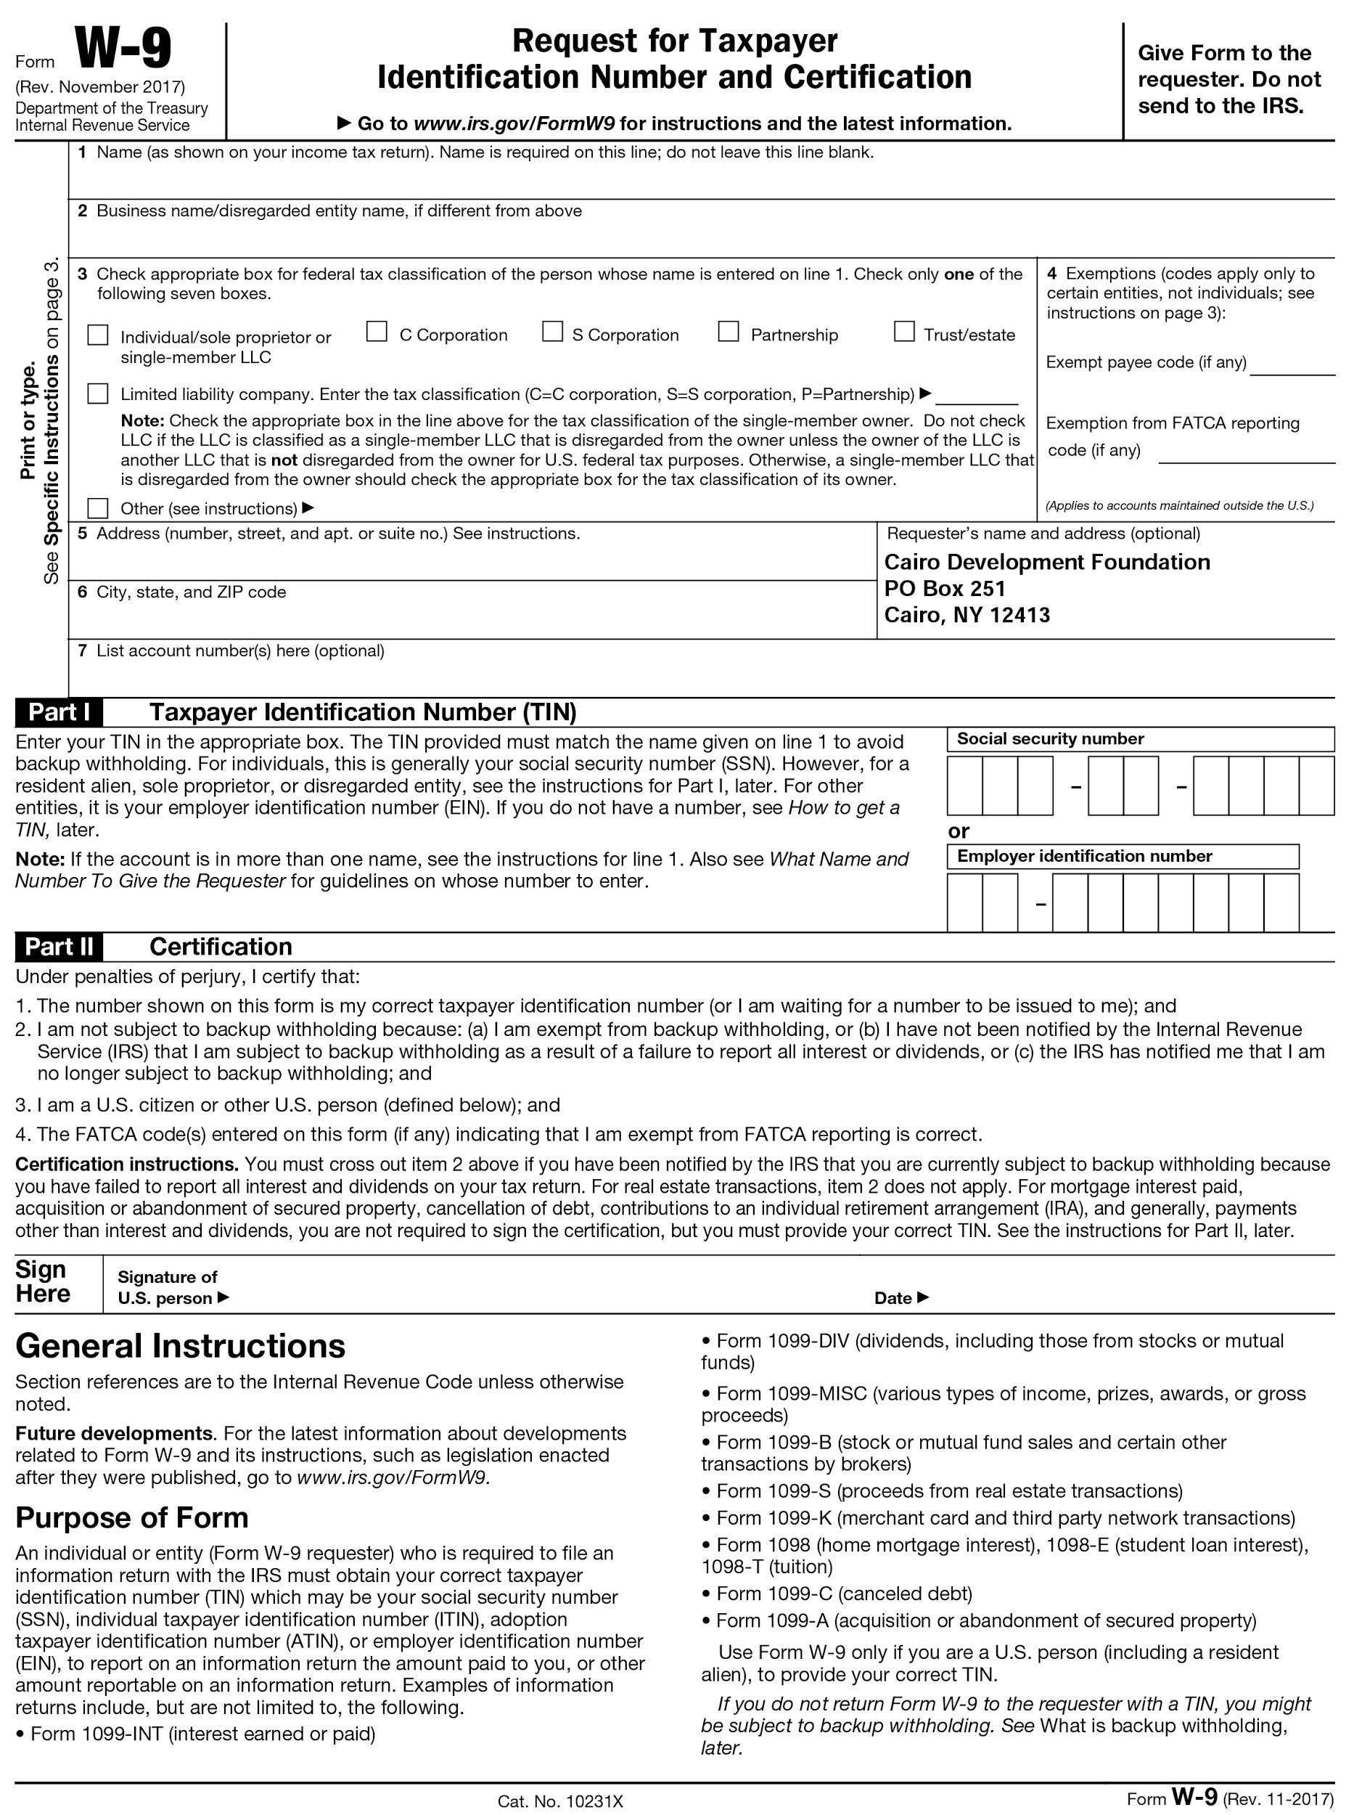
Artist Guidelines, Technical Notes & Design Criteria
Think permanence and prepare for damage
by Time, Weather, and People!

Designs must be APPROPRIATE FOR PUBLIC DISPLAY
- The bears will be placed in highly public, accessible locations where the public can touch the designs. Public safety is a significant concern. Designs should be created with durability and safety in mind.
- Corporate logos and advertising are not permitted
- A review panel will evaluate all designs and has the sole discretion to accept or reject any design

PREPARATION
- Wash the surface of your bear to remove dirt and oils before beginning work.
- Check for holes to fill or defects in the surface that must be fixed before proceeding.
- Fill small holes with a bondo-type product. Smooth and let set before sanding.

EMBELLISHMENTS
- Must be Weather-Resistant.
- Affixed so it CAN NOT be pulled off.
- Vandals (and the weather) will try to remove add-ons, so think permanence.
- Artists may alter the basic Bear form but cannot compromise its structural integrity.
- The contact points at the base of the bear cannot be altered or obstructed.
- Structural alterations that result in fundamental change to the basic Bear form must be carried out under the direct supervision of an auto body shop or fiberglass fabricator.
- Epoxy 2-part clay such as Magic Sculpt or Epoxy Sculpt are recommended for sculpting forms onto your bear. Epoxy clay will harden to the same strength and hardness as the Bear form.
- DO NOT use Sculpey or similar clays that need to be oven or kiln dried.
- DO NOT use terra cotta clay, even if it says “Air-Drying.” It is too fragile and will crack to pieces!
- Props stick best to a clean, unpainted surface. If you have already painted your bear before adding props, use sandpaper or a wire brush to create a rough surface where you plan to attach props for better adhesion.
- Consider the weight of props before using. Heavy or bulky items tend to break off and make the bear difficult to lift and/or transport.
- Every time your bear is moved or loaded into and out of a vehicle it is vulnerable to damage. Warn anyone who may help you move your bear NOT to handle by any of the props that have been added to the bear. Props may look to an outsider like a permanent part of the bear, but they are prone to popping off if handled without the proper care.
CLOTHING, HATS, FABRIC, OR PAPER EMBELLISHMENTS
- Hats, bags and other items made of fabric may deteriorate outside. Weather-proof any fabric with a fabric hardener such as Paverpol, Amazing Fa-Brick OR Powertex. Do not use fabric hardener spray since it will not last or harden material enough to weatherize it.
- Fabric may fade when left out in the sun for long periods of time. Consider using paint instead of fabric or paper so your designs don’t lose their bright colors over the duration of the summer
- DO NOT USE PAPER OR CARDBOARD
- Varnishing with a coat of UV-1 gloss varnish, such as Lascaux or Liquitex, may deter fading

PAINT
- Recommended: Acrylics by Liquitex, Lascaux, Golden, Windsor-Newton, Daler-Rowney, Pebeo. and other professional grade Acrylic paint
- Oil-Based Paints are acceptable but allow sufficient time to dry before turning in your bear. Be sure to alert the staff at CDF if you have used Oil-Based Paints when you drop off your bear at the CDF Headquarters at 467 Main Street in Cairo. A different clear-coating process is used for Oil-Based paints, so they need to be aware.
- Avoid all latex paints!

ADHESIVES
- Common polyester and polystyrene body fillers such as Bondo and Evercoat are excellent for use both as an adhesive and as a material for sculpting shapes and textures on the bear.
- Liquid nails and other construction adhesives may be used as well, although the drying time is longer.
- For optimum bond, we would recommend that adhesives and fillers be used on the fiberglass itself prior to any priming or painting.
- PLEASE USE A TWO-PART EPOXY GLUE TO SECURE ITEMS THAT NEED TO BE GLUED. J-B WELD CLEAR OR ANOTHER TWO-PART EXPOXY GLUE IS RECOMMENDED.

CLEAR-COATING
- Protect your artwork before your bear leaves your studio by spraying with a coat of acrylic such as Krylon
- DO NOT use Lascaux UV-1 gloss varnish!
- Do not clear-coat over mosaic or mirrored surfaces. Mosaic bears will not be clear coated.
- If you use oil-based paint, please notify the CDF committee when you drop off your finished Bear for clear coating.
- The Cairo Bears Committee has arranged for a final auto-body clear coat of your bear at
Quality Auto Body located at 6316 NY-32, Cairo, NY 12413.
- Contact Sherry B. True 410-935-0072 before dropping off your bear at the CDF Building. We will arrange for photos to be taken before your bear is taken to Quality Auto for clear coating.

Standing Bear - 36” Tall
Front or Back (choose at least one)
Artist:________________________________ Bear Title:______________________________________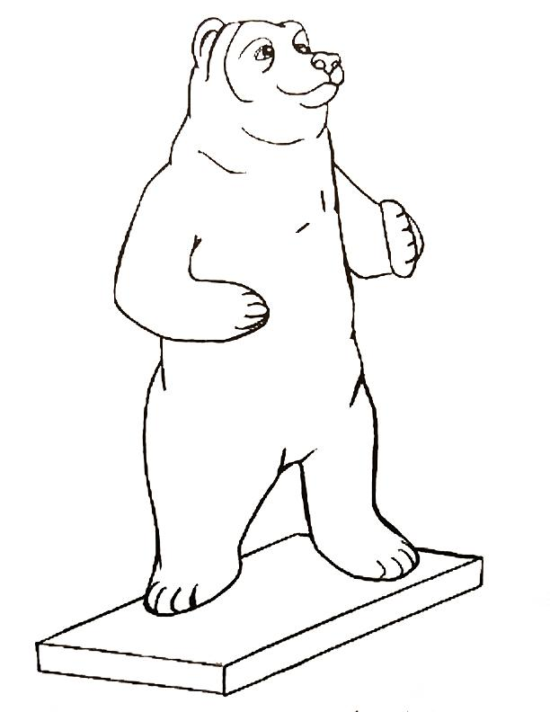
Standing Bear - 36” Tall
Front or Back (choose at least one)
Artist:________________________________ Bear Title:_______________________________________
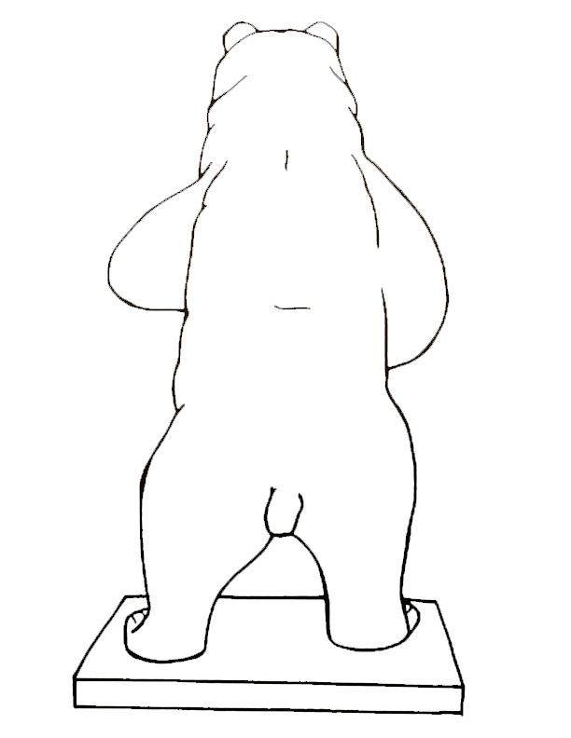
Sitting Bear 21” Tall
Front, Back or Side (choose at least one)
Artist:________________________________ Bear Title:_______________________________________
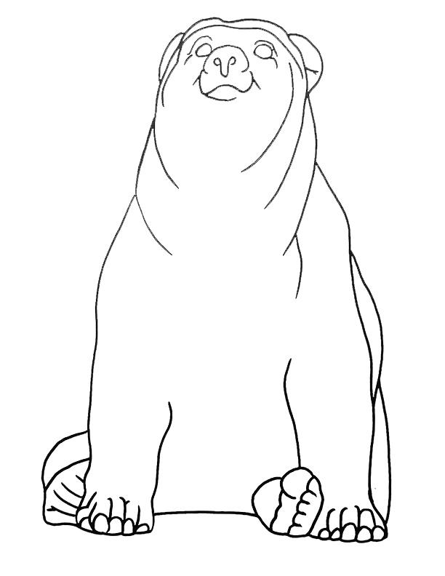
Sitting Bear 21” Tall
Front, Back or Side (choose at least one)
Artist:________________________________ Bear Title:_______________________________________
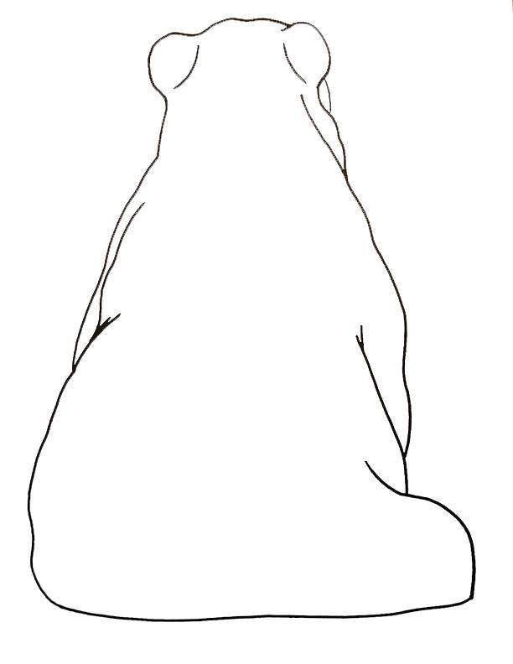
Sitting Bear 21” Tall
Front, Back or Side (choose at least one)
Artist:________________________________ Bear Title:_______________________________________
